- CONSIDER, Burst size = 1.5 kbyte = 1536 byte.
Write frequency = 100MHz.
Depth = 1kbyte=1024 byte.

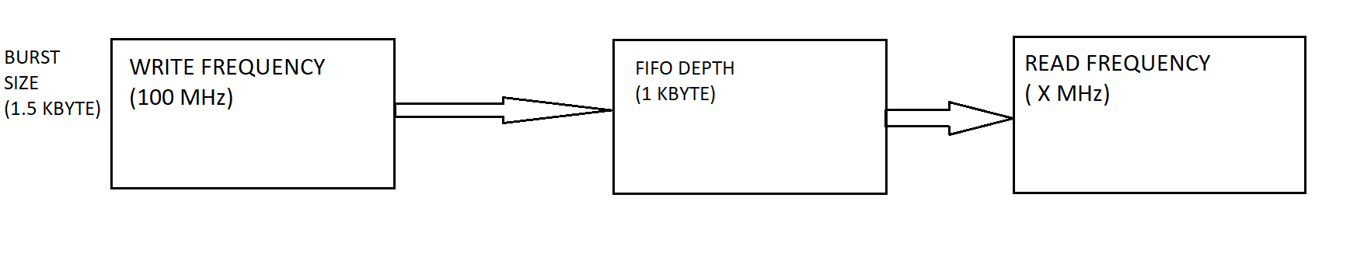

- Time taken to write 1 data = (1/10MHz)=10 ns.
- Time taken to read 1 data = (1/x ) = y ns.
- Time taken to write 1.5kbyte (1536byte) data = 1536*10 ns
= 15360 ns.
- In same time b was able to read = (15360/y) bytes.
- So, the remaining data must be stored = 1024 byte = [1536 byte -(15360/y)]
- Hence, time taken to read 1 data = y = 30 ns.
- Read frequency = (1/30ns )= 33.3MHz.

